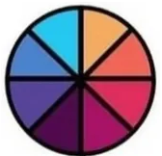



***WEDGE TOKEN***

WHITEPAPER

1.INTRODUCTION

1. Wedge uses BEP-20 Binance network, and is a decentralised application platform, solution for small and medium businesses to help grow and scalability projects. The system’s distinctive features are connected using BEP-20 network, token: WDG. The creator and owner, who has more than 20 years experiences in Finance, who currently runs three businesses in UK, provides the best outcome and cost optimization that aim to provide a seamlessly, crystal clear and smooth process to make sure that the client that decide to invests gets the best advice in terms of cost optimisation, growing, and scalability plan for the next 5 years; we offer a consistent support for small and medium businesses as well as bespoke solutions for corporates and institutions; this is what we do from 1995.
2. Designed to make apps usable on the web, the network runs on a Proof-of-Stake (PoS) consensus mechanism, which aims to offer scalability, stable and low fees.



2. PROJECT STORY

In 2020, DeFi (Decentralized Finance) made a big step in blockchain innovation roadmap, and many investors got high returns from that. However, many DeFi products are used mainly by those with high literacy, and the current situation is that there are high hurdles for the general public to use them.

WEDGE TOKEN FINANCE aims to be an ecosystem that is easy to handle even for the general public, offering solutions.



3. WEDGE System Structure

WDG is the native utility token that is used for:

1. Provide seamlessly finance bespoke solutions for start-ups, as well and small and medium entities.
2. Using the “Full Life Cycle” system on business analysis (test, run, check, retest and rerun), to assure completeness.
3. Used for governance votes to determine how network resources are allocated.



4. ECOSYSTEM

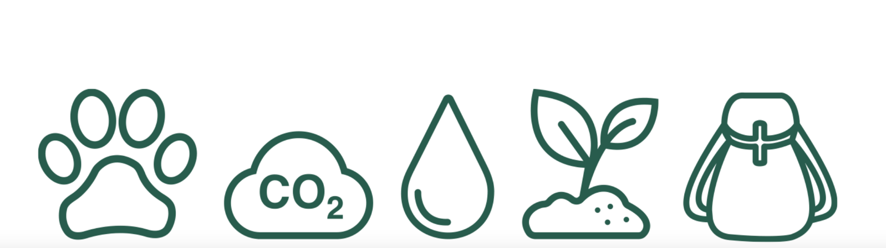

The ecosystem comprises:

WEDGE FINANCE (current),

WEDGE BUSINESS (early Dec 2021) and

WEDGE FULL LIFE CYCLE (late January 2021).

At full regime, these elements will be linked together using upper layer applications, and cloud edge system, to catalyse data, assuring optimal results are delivered to the client.



5. WEDGE TOOLS

1. WEDGE Interface – That allows clients keep up of the project status.
2. WEDGE Explorer – To both comparison past experience and the understanding of project actual performance.
3. WEDGE Command – Designed to allow clients interact directly with the project and revert back on the idea.



6. TOKENOMICS

Total Supply: 10,000,000,000,000 Tokens

75% Circulating Supply

2.5% Locked

2.5% Burned

10% Owners

10% Marketing and research

WEDGE Token launched its BEP-20 network on the September 27th, 2021; 10 trillion WEDGE tokens created at genesis. 5% of additional supply is issued each year to support the network as epoch rewards, of which 90% goes to validators (4.5% total) and 10% to the protocol treasury (0.5% total).

Protocol Fees

The system applies a fee of 0.3% for every trade, and this amount is divided into 3 parts:

* 0.2% is for liquidity provider fee
* 0.05% is rewarded with S-ONE token (government token of the system)
* 0.05% is for ecosystem fund

Liquidity Provider tokens

By adding liquidity to S-ONE Swap, users get back their Liquidity Provider (LP) tokens. The number of LP token is calculated using the formula:

LP token = (A*B) ^0.5

In which:

* A: the number of token 1
* B: the number of token 2 of the pair

The LP tokens are ERC20 tokens and can be used to trade, stake, or provide liquidity to other ecosystems.

7. ROADMAP

Q3 2021. Deploy the smart contract and Launch Pool and Farm in Pancake Swap

Q4 2021. Twitter, Instagram, Building Telegram community

Devs team will work on the platform and release new features by the end of Q3.

Q1 2022. The platform will launch, and the community will have the power over

WEDGE projects taking place in the real world.

Q2 2022. After a community vote, projects will commence in physical form within the real

world.